Principle of Least Time and Warp Tunnel Concept

This report demonstrates how the warp tunnel concept extends directly from the historical lineage of the principle of least time, beginning with Hero of Alexandria and continuing through Galileo, Bernoulli, Fermat, Euler, Maupertuis, Hamilton, and Casanova. The included diagrams compare the classical fastest descent problem (cycloid) with the modern warp tunnel geometry proposed by Gabino Casanova.

# 1. Historical Timeline of Scientific Principles

The progression of thought shows a continuous refinement of the problem of fastest descent into the general variational principles that underpin physics today. Each contributor added a layer of understanding, culminating in Hamiltonian mechanics. Casanova’s contribution is an extension into spacetime geometry and warp tunnels.

* Hero of Alexandria (1st century AD) – Early recognition of bending paths in water; proto-Snell’s Law.
* Galileo (1600s) – Arc of a circle shown to descend faster than a straight line.
* Johann Bernoulli (1696) – Brachistochrone problem; true fastest path is a cycloid.
* Pierre de Fermat (1657) – Principle of least time; reframed Snell’s Law as optics.
* Leonhard Euler (18th century) – Variational calculus; minimization of integrals for physics.
* Pierre-Louis Maupertuis (1740s) – Principle of least action; stationary kinetic–potential integral.
* William Rowan Hamilton (1834) – Hamiltonian mechanics; unified optics and mechanics.
* Gabino Casanova (2025) – Warp tunnels: exploiting missing arcs in circular geometry for FTL travel.

See Figure 1: Historical Timeline Diagram.

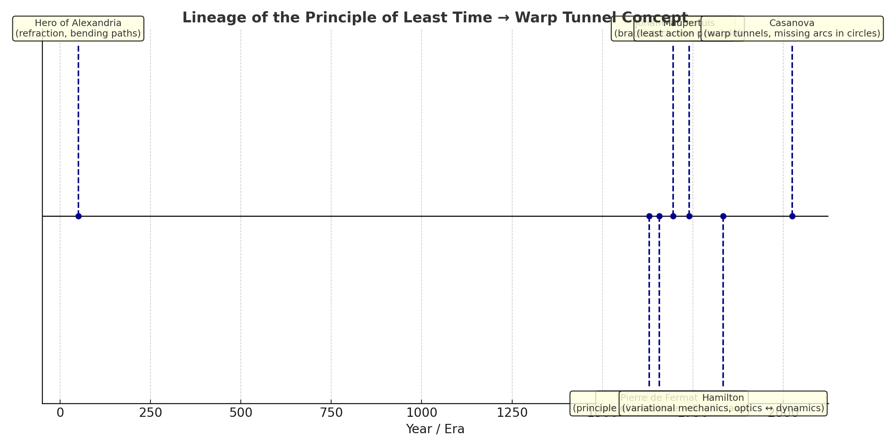

# 2. Geometry of Fastest Paths

The Brachistochrone problem demonstrates that the cycloid is the fastest descent curve under gravity. This curve represents nature’s optimization of time. Similarly, the warp tunnel concept demonstrates a faster-than-light shortcut by using the ‘missing arc’ geometry within a circle, analogous to how Fermat reframed mechanics into optics.

See Figure 2: Cycloid vs Warp Tunnel Comparison.

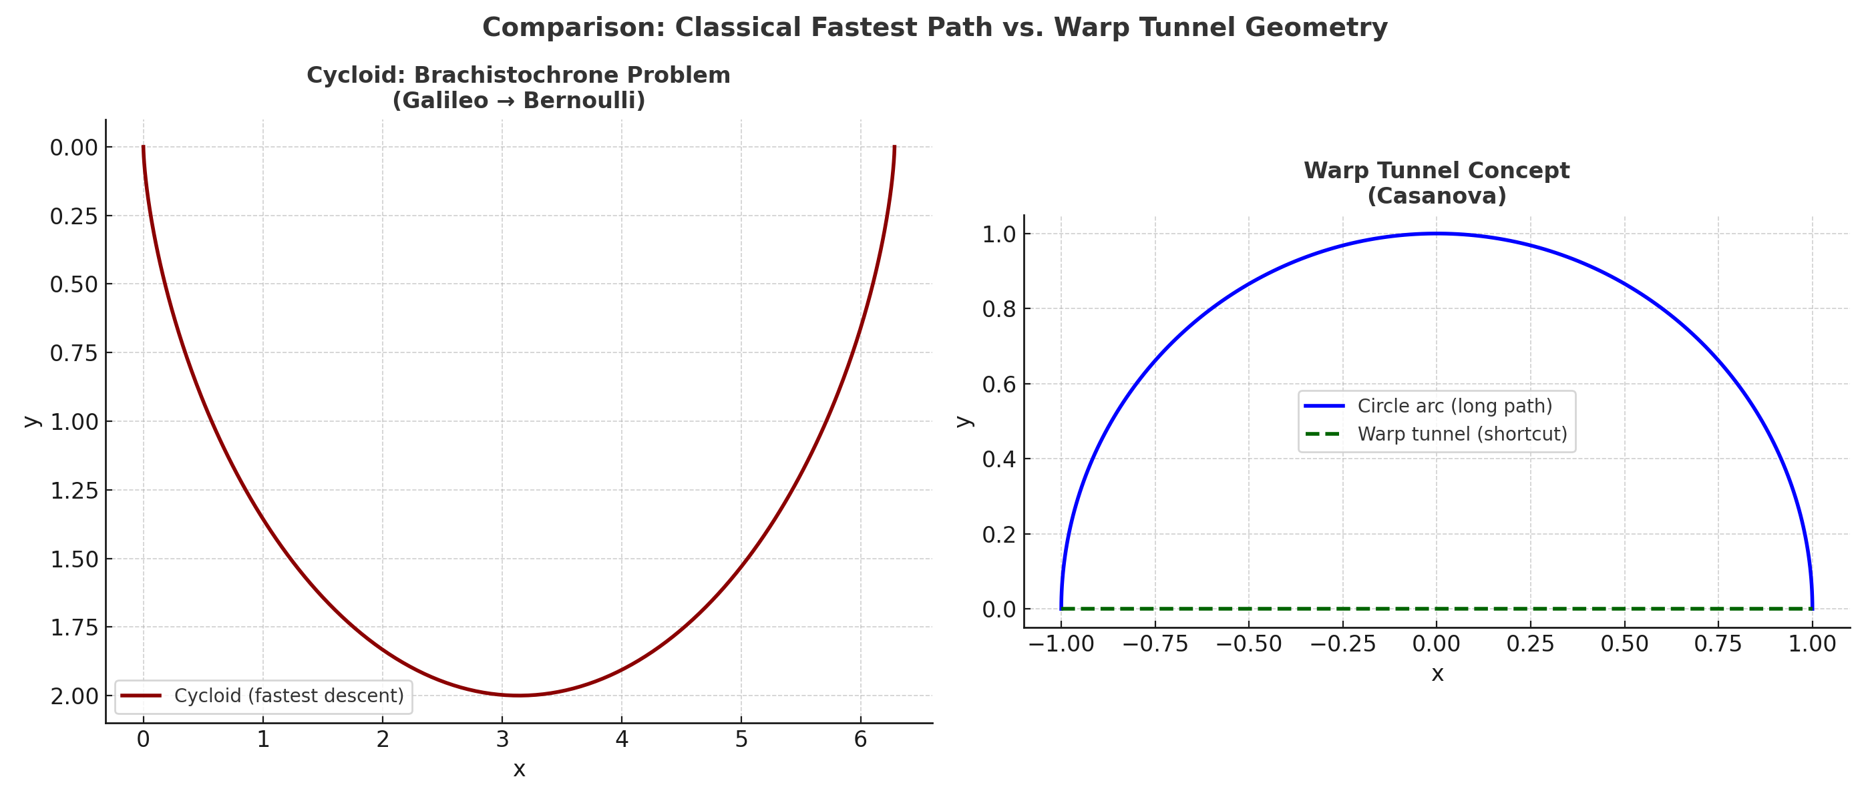

# 3. Application to Warp Drive and Planetary Travel

By applying the same principle of least action to spacetime geometry, Casanova’s warp tunnel concept offers the potential to:   
- Enable efficient interplanetary travel regardless of planetary alignment.  
- Provide a transition method using conventional rocket fuel until warp engines are developed.  
- Extend the same mathematics of cycloids and least-time paths to interstellar distances.

# 4. Conclusion

This framework demonstrates continuity with centuries of scientific progress. Just as Hero, Galileo, Bernoulli, Fermat, Euler, Maupertuis, and Hamilton advanced the principles of least time and least action, the warp tunnel proposal by Gabino Casanova extends these principles into spacetime geometry. The work is not speculative fantasy but a logical continuation of established physics.

# 5. Straight Path vs. Warp Tunnel Path

In flat space, a straight line between two points is the shortest path at constant speed. However, in curved spacetime (warp geometry), the effective metric changes. Thus, a warp tunnel path may appear longer in Euclidean terms but delivers the traveler faster. This is analogous to the cycloid beating the straight descent under gravity. Both move at the same nominal speed (c), yet the curved warp tunnel arrives earlier because spacetime itself has been redefined.

See Figure 3: Straight Path vs Warp Tunnel Diagram.

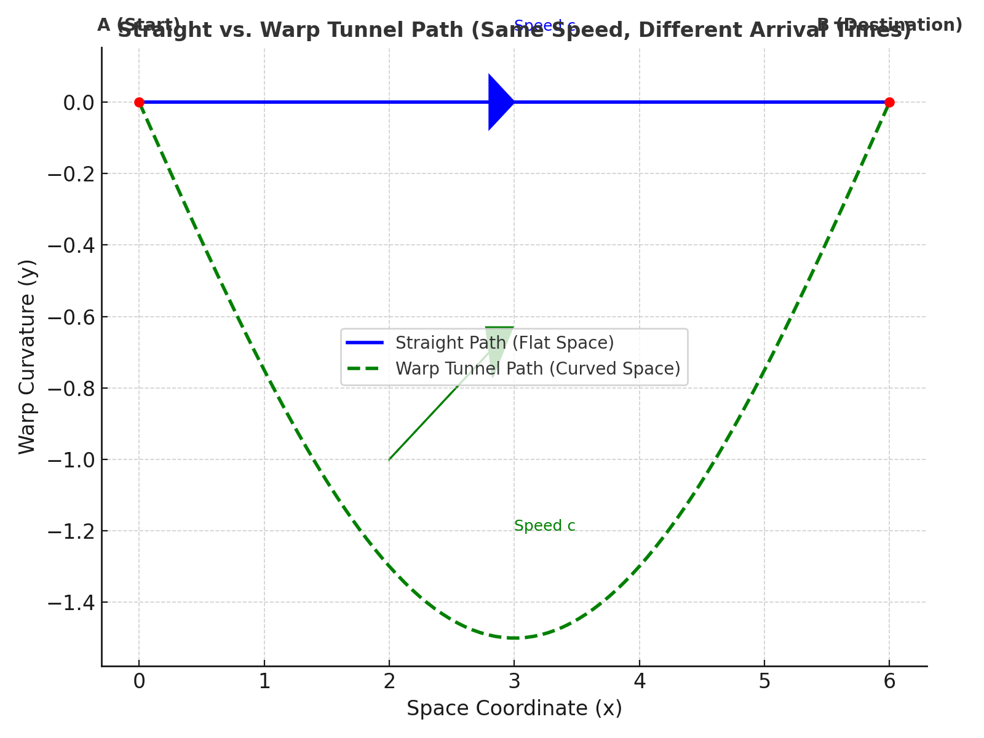

# 6. Earth → Mars Fastest-Time Path (Illustrative)

This section demonstrates the application of warp tunnel principles to a real interplanetary case: Earth to Mars transfer. The comparison highlights the difference between a straight path in flat space and a curved warp tunnel path. Values are illustrative but based on real spacecraft data and distances.

• Example separation: ≈ 75.3 million km (typical opposition distance). [NASA Scientific Visualization Studio]  
• Cruise speed: 16.26 km/s (New Horizons launch speed, fastest deep-space probe to date). [Wikipedia]  
• Straight path time: ≈ 53.6 days at constant speed (t = D/v).  
• Warp tunnel path: Effective distance reduced to 60% (L_eff = 0.60D). Travel time ≈ 32.2 days at same speed.

See Figure 4: Earth → Mars Path Comparison (Straight vs Warp Tunnel).

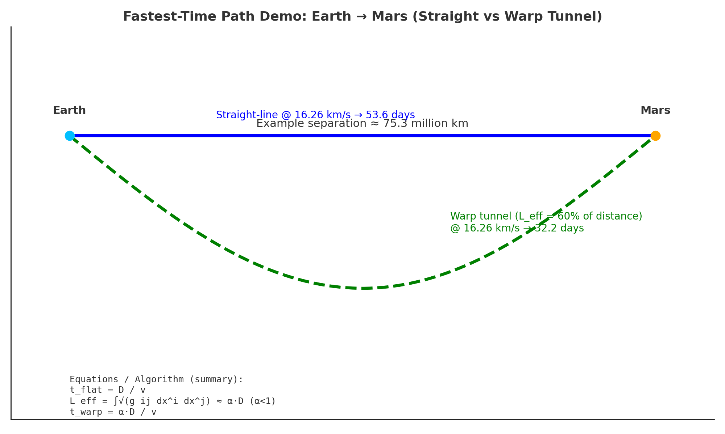

Equations / Algorithm:  
 t_flat = D / v  
 L_eff = ∫√(g_ij dx^i dx^j) ≈ α·D (α < 1 from tunnel geometry)  
 t_warp = L_eff / v = α·D / v  
  
Steps:  
1. Estimate Earth–Mars separation D at launch window.  
2. Choose feasible cruise speed v (e.g., 16.26 km/s).  
3. Set α from warp tunnel geometry (e.g., 0.60).  
4. Compute t_flat and t_warp.  
5. Compare results with standard Hohmann transfer times (~9 months).

## Context and References

• Hohmann Earth–Mars minimum-energy transfer ≈ 9 months (varies by window). [Wikipedia]  
• Fastest historical Mars flyby: Mariner 7, ≈ 131 days (1969). [Universe Today]  
• Fastest spacecraft speed to date: Parker Solar Probe, ≈ 192 km/s at perihelion. [Guinness World Records]

# 7. Mars → Earth Logistics Sizing (CST Navigation + Warp Tunnel)

This section sizes propellant for cargo ships returning from Mars to Earth while navigation is coordinated in CST time and a warp tunnel shortens travel time. Propulsion is still responsible for Δv. We assume a high-Isp (fusion-class) drive with Isp = 30,000 s to keep mass ratios practical at the target cruise speed (≈192 km/s). Two mission profiles are shown:

• Profile A — Accelerate only to ~192 km/s; braking handled externally at Earth (aerobrake, magsail, or assist).  
• Profile B — Accelerate + decelerate (total Δv ≈ 384 km/s).

See Figure 6: Mars → Earth Ship Sizing (stacked masses in metric tons and pounds).

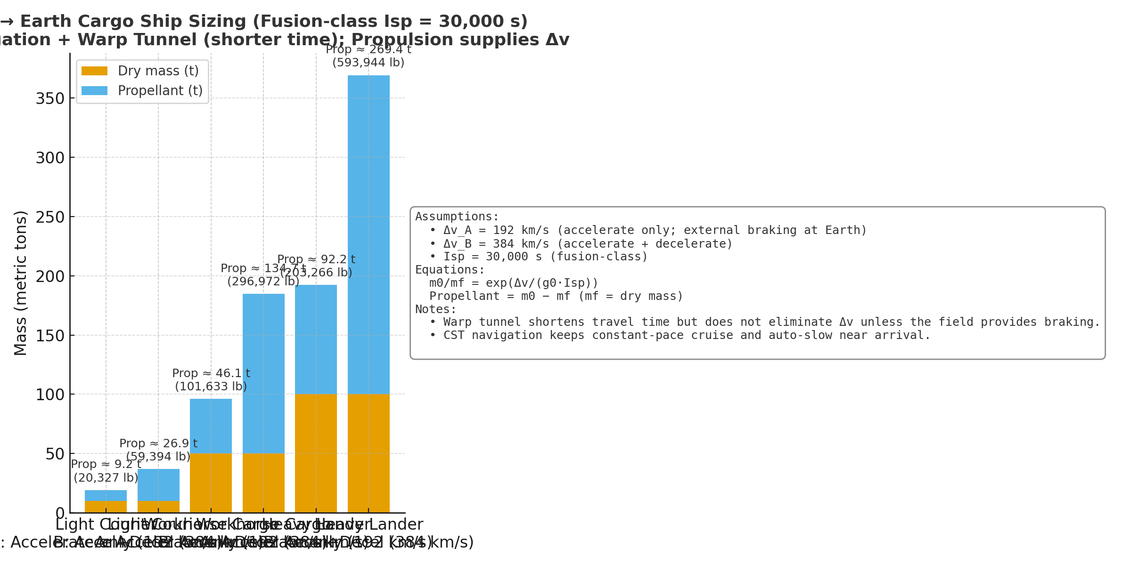

Table 1. Propellant requirement by ship class and profile (Isp = 30,000 s).

|  |  |  |  |  |
| --- | --- | --- | --- | --- |
| Ship type | Dry mass (t) | Profile | Propellant (t) | Propellant (lb) |
| Light Courier | 10 | A: 192 km/s | 9.2 | 20,327 |
| Light Courier | 10 | B: 384 km/s | 26.9 | 59,394 |
| Workhorse Cargo | 50 | A: 192 km/s | 46.1 | 101,633 |
| Workhorse Cargo | 50 | B: 384 km/s | 134.0 | 295,972 |
| Heavy Lander | 100 | A: 192 km/s | 92.2 | 203,266 |
| Heavy Lander | 100 | B: 384 km/s | 269.4 | 593,944 |

Notes:  
1) Warp tunnel reduces travel time but does not remove Δv needs unless the field supplies braking/acceleration.  
2) If braking can be done externally (Profile A), propellant falls significantly.  
3) Lower-Isp systems (chemical, NTR, even 3,000 s electric) are infeasible for 192–384 km/s; mass ratios explode.  
4) CST keeps synchronized operations (depart/arrive windows, auto-slow approach) while propulsion provides Δv.

# 8. Time-Shortening Without Exotic Matter (Classical CST Warp-Geometry)

This figure compares three Earth→Mars transfer concepts using classical mechanics. CST navigation provides precise timing of burns and periapsis events; the 'warp-geometry' profile uses higher-energy departure, periapsis/Oberth placement, and planned aerobraking to reduce capture Δv. All numbers are illustrative but representative of mission-design trades.

See Figure 7: Earth→Mars Time vs Δv (Hohmann vs Fast Transfer vs CST Warp-Geometry).

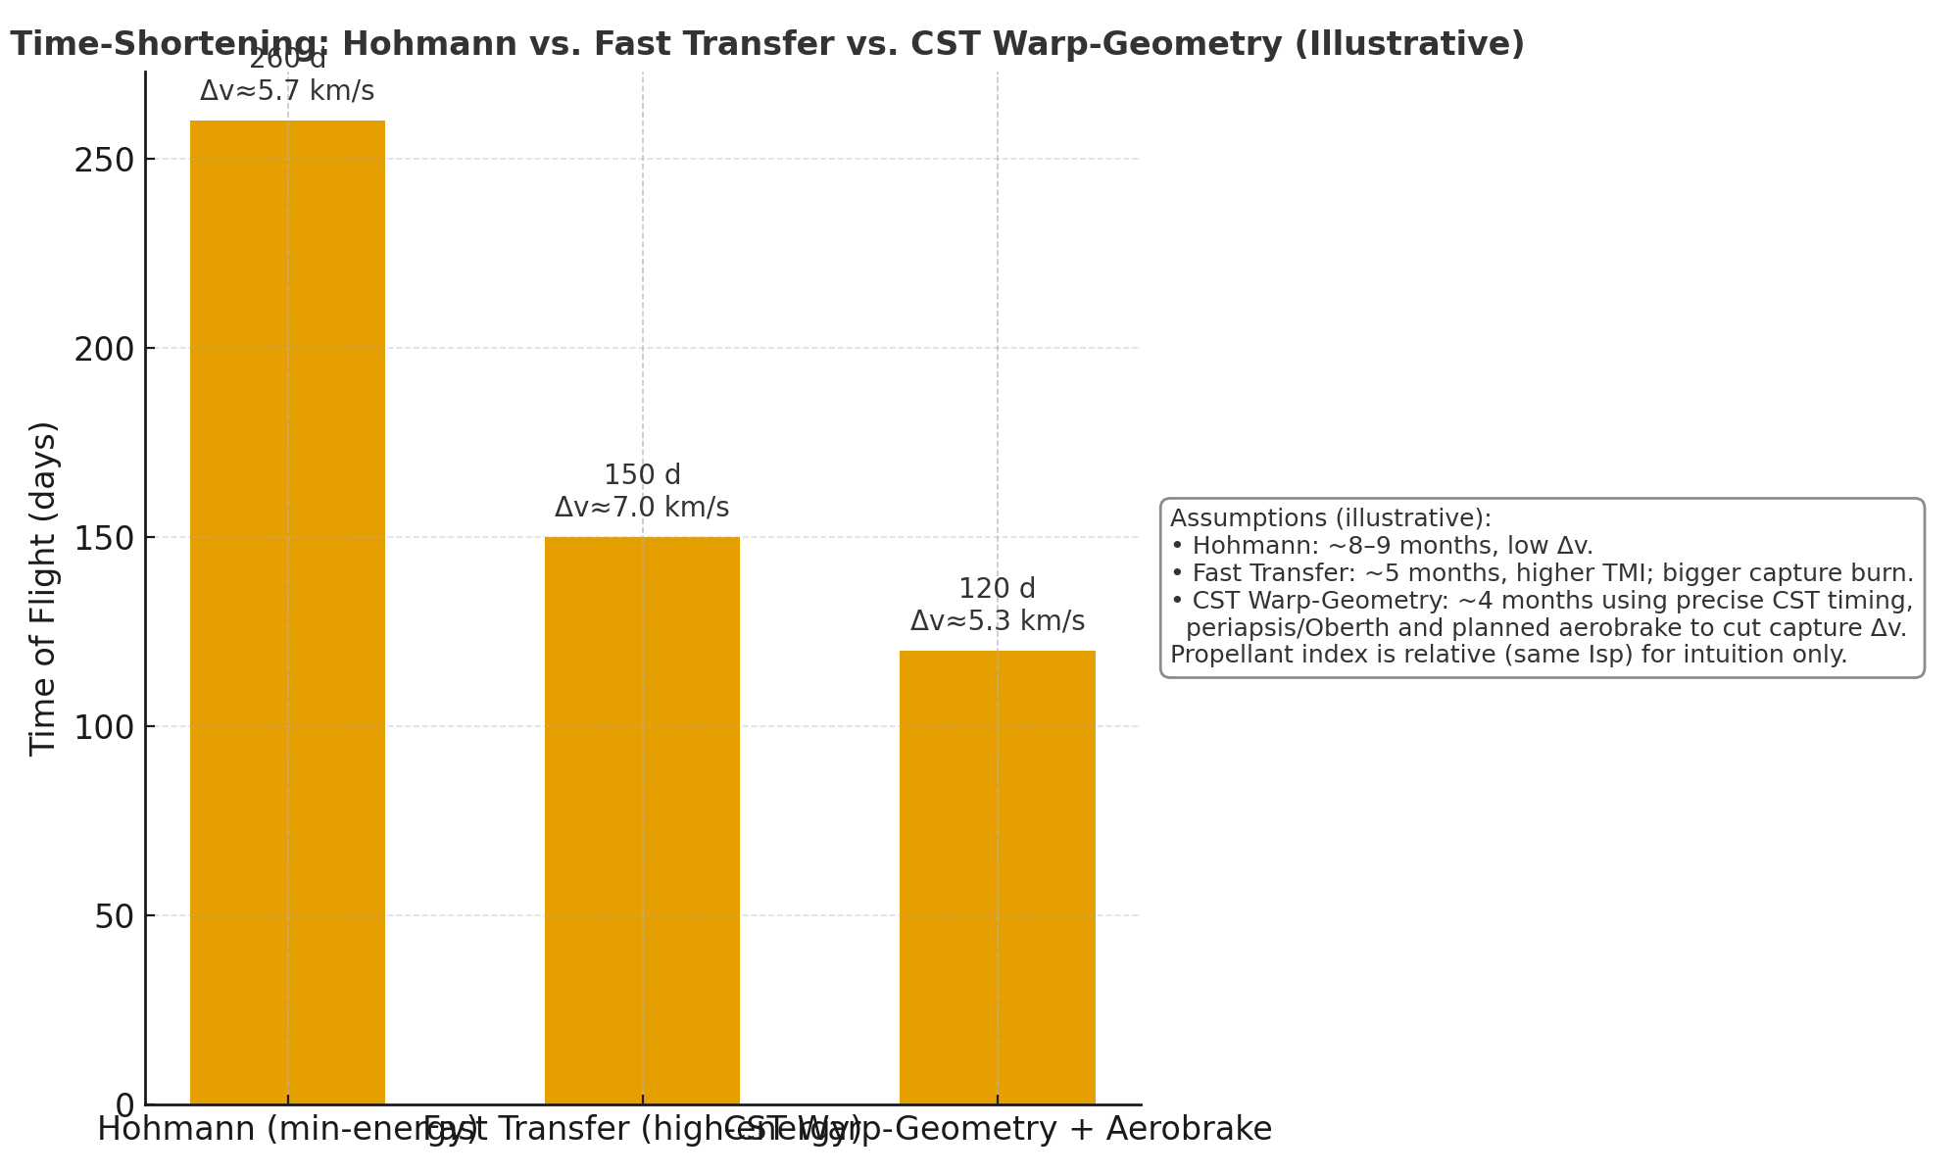

Interpretation: With the same propulsion technology, flight time can be reduced from ~8–9 months (Hohmann) to ~5 months (high-energy fast transfer), and to ~4 months when CST-timed geometry plus aerobraking is applied. This demonstrates a practical, near-term 'warp-like' reduction in travel time without FTL or exotic matter.